**Analysis Topic 6 – Assignment 6**

**System Analysis & Design & CIS-2245**

|  |  |
| --- | --- |
| Author: | Christopher Sigouin |
| Date: | September 20, 2015 |
| Due Date: | September 19, 2015 |
| Assignment: | Analysis Topic 6 |
|  |  |
|  |  |
| Mark: | __________ |

**QUESTIONS:**

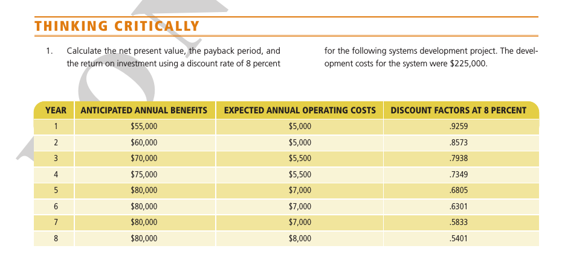

**RESPONSES:**





